Novel FABRICATION Method FOR suspended MEMBRANE MICROSTRUCTURES ON PRINTED CIRCUIT BOARDS

Wire bonding and surface routing present major limitations in the fabrication of high-density MEMS structures with large number of contacts. This work proposes a novel, simple, and low-cost method that allows the deposition of high-density MEMS suspended on membranes without routing limitation and wire bonding steps. The potential of this technology is demonstrated by fabricating membrane suspended microheater structures. The microheaters are deposited and patterned on a polymer film after it is laminated onto a printed circuit board. The unique approach is suited for a broad range of MEMS architectures, including the presented through substrate vias and membrane structures.

**Background**

Typical MEMS fabrication processes consist of depositing and patterning thin film and silicon structures on large wafer substrates which are divided into single units (dies). These dies are subsequently electrically connected to larger scale electronic components, such as printed circuit boards (PCBs). The prevalent wire bonding technology has two major limitations: (i) low production rate, owing to the point-to-point processing and (ii) poor usage of available surface area due to surface routing of conductive traces and the arrangement of bond pads on the die, limiting the number of MEMS units on a single die. The alternative through silicon via (TSV) technology is linked to high cost and complexity.

The presented technology replaces conventional microfabrication substrates with a polymer film laminated onto a PCB, onto which the membrane suspended MEMS structures will be deposited using conventional microfabrication processes [Fig1]. Circuit boards with vias, traces, and milled structures (e.g. cavities) are easily obtained or fabricated for a fraction of the cost of conventional microfabrication substrates.

This work presents a low cost, and simple solution to deposit and contact MEMS immediately to PCBs, improving the surface area usage of surface routing. By contacting through the polymer film to the PCB, a high surface density of different MEMS units on the device substrate can be achieved, which would otherwise be limited by trace resistance, width, and count. The potential of the invention is demonstrated by fabricating membrane microheaters that are directly contacted to a PCB substrate.

**Fabrication method**

In a first step, an application specific PCB is designed according to the required dimensions and layout of the MEMS devices, including through vias and non-plated through-holes for membranes (Fig 2a). A fluorinated ethylene propylene (FEP) coated polymer film (Kapton FN, Dupont) is subsequently laminated onto the PCB using a heat press (Figure 2b). The membrane structures result from the polymer film laminated across the non-plated cavities in the circuit boards. Both PCB and polymer film materials must be vacuum process compatible for the subsequent fabrication steps.

For standard microfabrication equipment compatibility and handling, the PCBs are mounted onto a reusable carrier wafer. The polymer film is then patterned with a dry etching process, revealing the underlying PCB copper pads (Figure 2c and 2d). The platinum microheaters are deposited and patterned using standard sputtering and lift-off processes, respectively. The contacting of the heater structures to the PCB through the polymer film openings is realized with an additional aluminum sputtering and lift-off process (Figure 2e). Finally, the heaters are encapsulated by laminating a second Kapton film onto the surface onto the device (Figure 2f).

**Experimental Results**

The devices were visually inspected under an optical microscope (Figure 3) and tested for functionality by measuring the resistance between corresponding copper pads connected to the single heater structures. Temperature profiles showing the fast response time of the microheaters were recorded (Figure 4). Finally, infra-red photography was used to create a heat map of the functional microheater (Figure 5).

Future work is carried out to create large array patterns and to demonstrate the potential of the presented technology to fabricate a multitude of microsensors and actuators, including micro-valves, hot film anemometers, and pressure sensors.

**Questions**

* We did a lot of experimentation during the process development (for example: different lamination temperatures to figure out best adhesion, different etch mask materials, soft-baking in the oven instead of the hotplate, development times etc.). These experiments took a lot of time and effort. Can this information be put in the fabrication method, or just the end results? If you can make graphs out of that and have solid quantifiable data (not just sticks/doesn’t stick) yes. If not, just the end results matter.
* For a fabrication paper what kind of data is appropriate to show apart from microscope images. Yield / Resistance spread / Response time / IR image? Yes, Yes and Yes. Additionally, everything about the morphology of the substrate (roughness) and other things might help

**Figures**

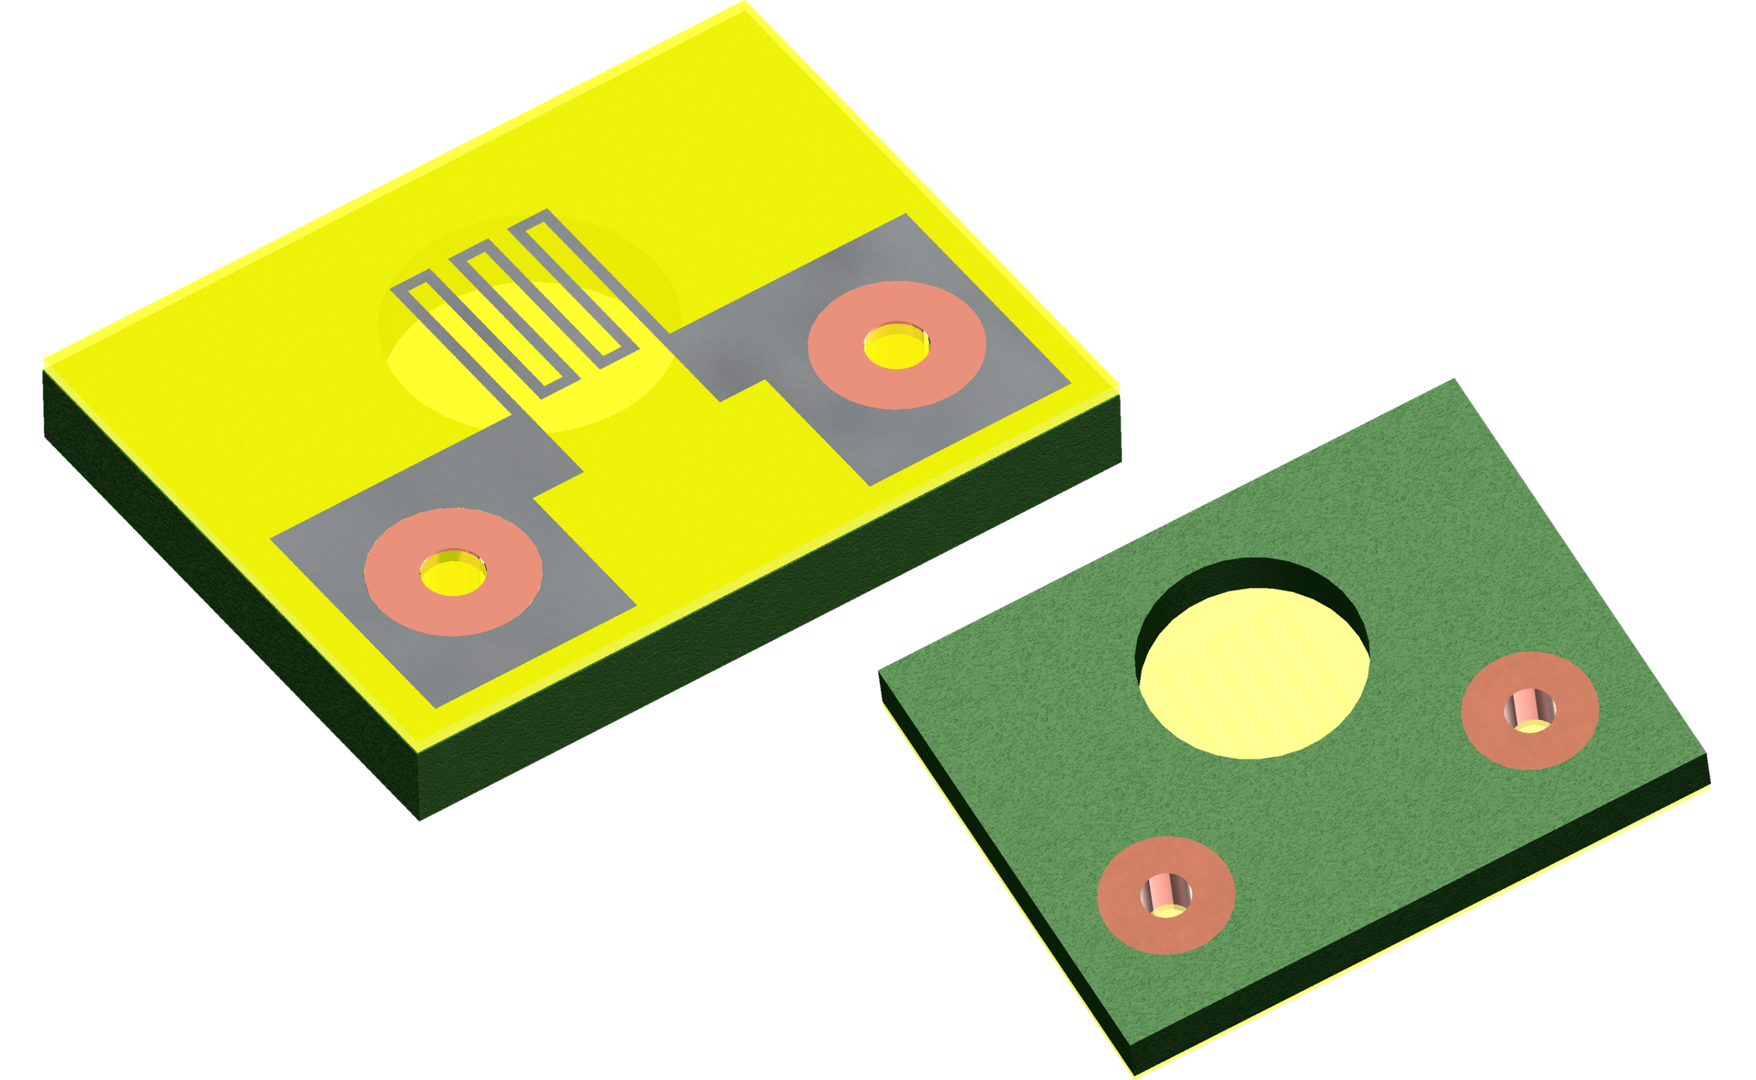

Figure 1: Conceptual PCB MEMS device

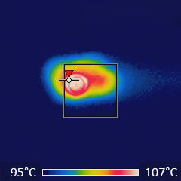

Figure 5: Infra-red image of a functional microheater; showing a uniform and highly localized temperature profile.

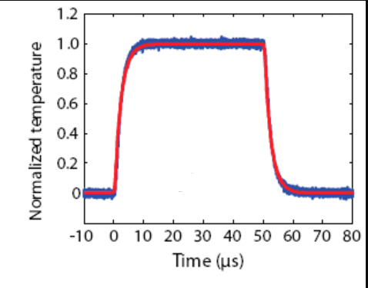

Figure 4: Thermal response of the microheater

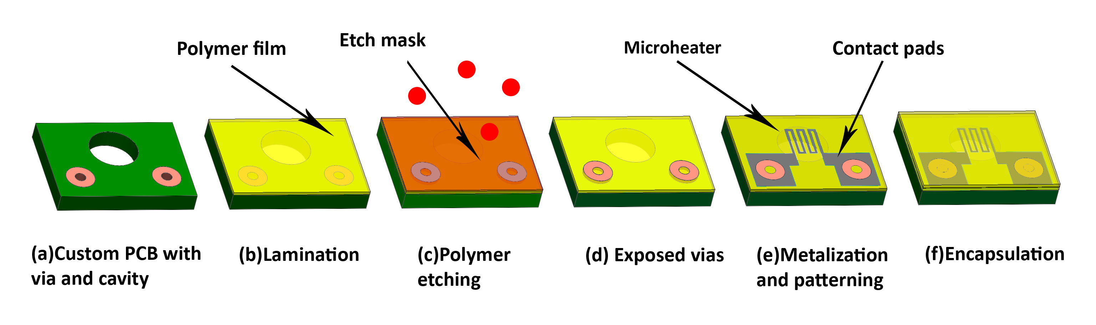

Figure 2: Fabrication process steps

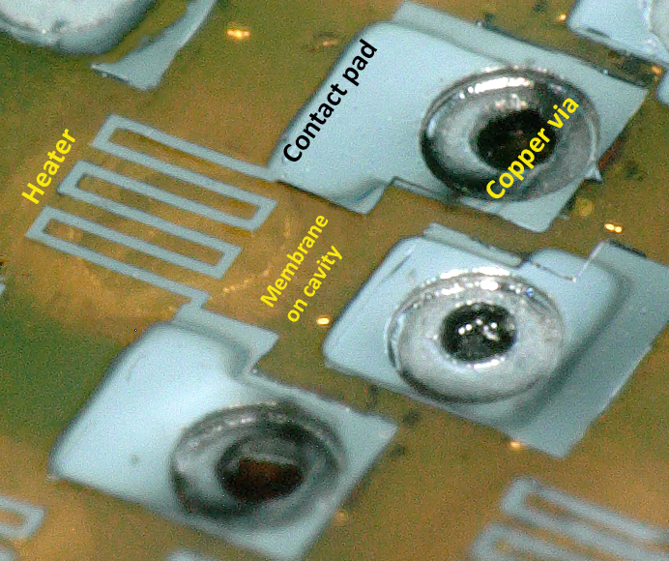

Figure 3: Close-up image of a single microheater

with contacts and membrane

